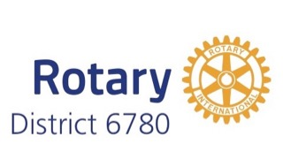 | District Grant Timeline  2022-2023 | 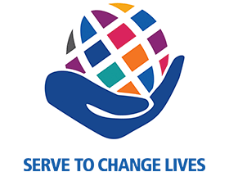

- Project Planning
  - President-elect year: the club identifies its District Grant project for Rotary Year 2022-2023

- Club Qualification
  - Two club members (President-elect and project lead recommended) attend district grant qualification training during Rotary year 2021-2022.
  - The Club Memorandum of Understanding and Club Qualification Plan (one combined document) must be submitted for the grant proposal to be considered (may be submitted with the application).

- Application
  - Applications for the District Grants are accepted between October 1, 2021, and January 31, 2022.
  - Grants will be reviewed, and approvals announced beginning in February 2022.

- Funding
  - Clubs may expect to get a grant for half of the project cost, up to the club allocation.
  - Projects which have not been started by October 2022 (unless consistent with the application timeline) may be cancelled so the funds can be offered to other clubs.

- Execution
  - Work on your project may not begin until the club has been notified by the District that The Rotary Foundation has approved the District 6780 district grant package for 2022-2023! This should occur by June 1, 2022.
  - Plan for the project to be completed by March 2023.

- Progress Report
  - A progress report is due on October 1, 2022.

- Completion
  - Project must be completed by March 31, 2023.

- Closing Report
  - A final report with receipts should be submitted within two months of completion of the project, but no later than May 31, 2023.
  - Reimbursement by the District grant will occur after the final report is approved and the funds have been transferred to the District by The Rotary Foundation.

